

NAAN MUDHALVAN
DIGITAL MARKETING
V.R.S COLLEGE OF ENGINEERING AND TECHNOLOGY
ARASUR - 607107
DEPARTMENT OF ELECTRICAL AND ELECTRONICS
ENGINEERING

A.ARAVINDRAJA - 422720105302
P.MUKILAN - 422720105018
S.SANJAI - 422720105024
Y.SARANRAJ - 422720105025

1 INTRODUCTION
1.1 Overview
1.2 Purpose 2 PROBLEM DEFINITION & DESIGN THINKIND
2.1 Empathy Map
2.2 Ideation & Brainstorming Map
3 RESULT
3.1 Brand poster
4 ADVANTAGES & DISADVANTAGES
5 APPLICATIONS
6 CONCLUSION

INTRODUCTION

1.1 Overview
In order to create a compelling brand name and project description, it's essential to distill the essence of your endeavor into a concise yet impactful paragraph. Begin by defining your brand's identity, encompassing its values, mission, and unique attributes. Next, brainstorm potential brand names that resonate with this identity, ensuring they are memorable and aligned with your industry or niche. Simultaneously, consider your project's core purpose and what sets it apart from others. Once you've settled on a brand name, craft a one-paragraph project description that succinctly conveys your mission, target audience, and unique value proposition. The ultimate goal is to create a brand name and description that together encapsulate your project's essence and immediately capture the attention and interest of your audience.
1.2 Purpose
Logos are a point of identification ; they're the symbol that customers use to recognize your brand. A brand name is used by a company for a specific product or service. Brand names can be similar or the same as the names of company founders. The reason why this happens is because it aims to raise consumer awareness, promote brand loyalty and Visual Identity.
Logos are a point of identification; they're the symbol that customers use to recognize your brand. Ideally, you'll want people to instantly connect the sight of your logo with the memory of what your company does – and, more importantly, how it makes them feel. A strong brand purpose makes your brand stand out in a busy market. The why behind your what clarifies your brand's offering to consumers, and taps into important emotional connections that can foster a strong sense of brand loyalty amongst your consumers. Customers are less likely to invest in brands that are lesser known to them, while they purchase from the ones with more credibility, trustworthiness, and value.
2. PROBLEM DEFINITION & DESIGN THINKIND

  - Empathy Map

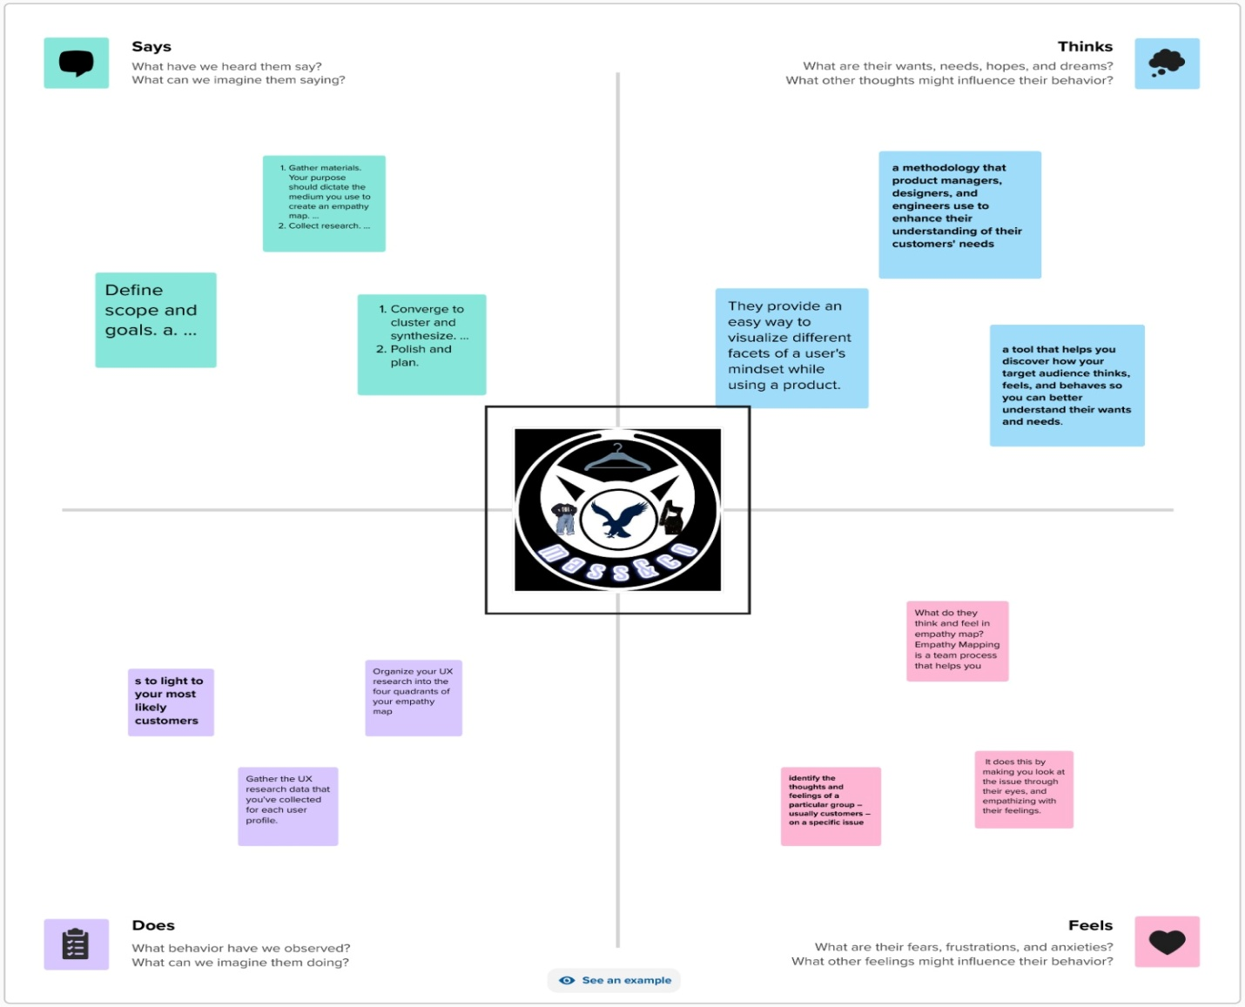

3 RESULT

3.1 Brand poster


4 ADVANTAGES & DISADVANTAGES
Advantages:
- Customer loyalty
- Credibility
- Accessible introduction of new products
- Branding makes your business memorable
- Increased marketing impact
- Protection from competition
- Attract appreciative customers
- Competitive advantage
- Customer recognition
- Retain top employees
- Brand reinforcement
- Improve company values
Disadvantages:
- Huge development costs
- Limited quality flexibility
- Changing the perception for the brand is hard

5 APPLICATIONS

- Logos are a point of identification; they're the symbol that customers use to recognize your brand
- It tells people the name of the company and it creates a visual symbol that represents your business.
- A brand name is used by a company for a specific product or service.
- It on your website, emails, letters, billboards, shirts, stickers, and more.

CONCLUSION
The brand logo is the symbol that customers use to recognize your brand. The canva is the best thing to create a logo and the brand name.

